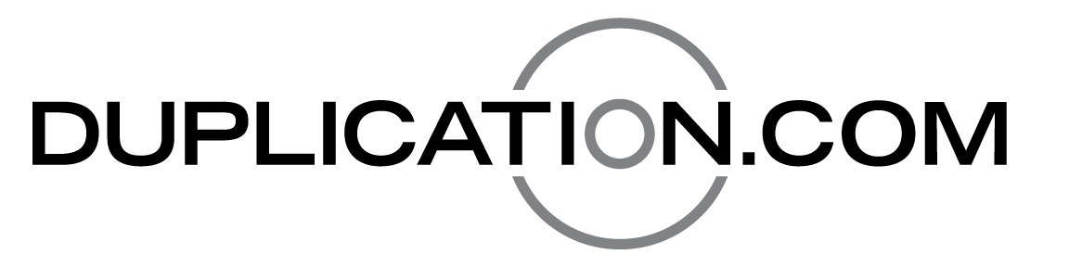
ANALOG MEDIA TECHNOLOGIES LLC
10111 Sweet Valley Drive, Unit 2
Valley View, OH 44125
TEL: (440) 333-0040
INFO@DUPLICATION.COM
COMMERCIAL CREDIT APPLICATION

Company name: _______________________________________________________________________________________________________________________

Head office or billing address: ________________________________________________________________________________________________________
________________________________________________________________________________________________________________________________________

Telephone: __________________________________________________________________ Fax: _____________________________________________________

Shipping Address (if different): _______________________________________________________________________________________________________
________________________________________________________________________________________________________________________________________

Owners/Directors: ____________________________________________________________________________________________________________________
___________________________________________________________________________________________________________________
____________________________________________________________________________________________________________________

Accounts payable contact: _____________________________________________________email: ________________________________________________

Who is authorized to issue purchase orders: _________________________________________________________________________________________

Primary bank: _________________________________________________________________________________________________________________________
Accounts: _____________________________________________________________________________________________________________________________

Trade credit references:
- __________________________________________________________________________________________________________________________________________________________________________________________________________________________________________________________
- __________________________________________________________________________________________________________________________________________________________________________________________________________________________________________________________
- __________________________________________________________________________________________________________________________________________________________________________________________________________________________________________________________

30 day credit limit requested: $____________________ Do you take early payment discounts? _________________________________________

I give Analogue Media Technologies Inc. authorization to contact the above credit references, and I agree to pay my account within the stated terms of sale and any interest charges (2% per month or the maximum permissible by law) due to late payment, as well as legal and collection fees.
Signature of owner or authorized person: ____________________________________________________________________________________________
Please print name: ____________________________________________________________________ Date: _________________________________________

